


A PROJECT REPORT
ON
GHUMANTEY: An application to Build Online Platform for booking guide
Submitted To:

Department of Computer Science and Multimedia
National College of Management and Technical Science
Samakhusi, Ranibari,
Kathmandu, Nepal

Submitted By:
Mr. Rahul Parajuli
Submitted in partial fulfillment of the requirements for the 7th Semester Final Project.

Date: December 2025
Kathmandu, Nepal

ABSTRACT
The tourism industry in Nepal, while a cornerstone of the national economy, faces significant challenges due to fragmented information, a lack of centralized booking platforms for local expertise, and the difficulty tourists face in finding verified, professional guides. Traditional methods of planning trips often lead to transparency issues and safety concerns for international and domestic travelers alike. To address these gaps, this project introduces Ghumantey, a comprehensive digital ecosystem designed to streamline the travel experience in Nepal. Ghumantey serves as a centralized bridge between tourists and the local tourism sector, offering a reliable platform for securing verified accommodation and professional local guides. A core innovation of the system is the integration of an intelligent chatbot designed to provide real-time, personalized assistance. This AI-driven feature suggests popular destinations, highlights cultural attractions, and recommends trusted guides based on user preferences, ensuring an interactive and tailored support system. Developed with a robust backend using Java Spring Boot and a modern, responsive frontend, the application prioritizes security, scalability, and seamless navigation. The system incorporates secure authentication and a dedicated dashboard for efficient management of bookings and service listings. By digitalizing the connection between travelers and local service providers, Ghumantey not only simplifies the logistics of trip planning but also promotes transparency and accountability within the industry. Ultimately, this project contributes to the digital transformation of Nepal's tourism sector, empowering local communities by increasing visibility for grassroots service providers and ensuring a safer, more enriched experience for every traveler.
Keywords: Java Spring Boot, Nepal Tourism, AI Chatbot, Verified Guiding

ACKNOWLEDGEMENT
The FYP report, titled “Ghumantey: A Digital Tourism Platform for Nepal”, was prepared in partial fulfillment of the requirements for the degree of Bachelor of Information Technology (Hons) at Lincoln University. I extend my deepest gratitude to my esteemed supervisor, [Insert Supervisor's Name], whose scholarly guidance, unwavering encouragement, and insightful feedback transformed this dissertation into its final form.
I also wish to express my heartfelt appreciation to all those who made this endeavor possible. My profound thanks go to my parents, family, and closest friends for their constant presence, moral support, and boundless affection throughout my thesis. Finally, I sincerely thank BIT Coordinator Mr. Roshan Bhatta, along with the entire faculty and staff of NCMT College, for their guidance, encouragement, and unwavering support, which proved indispensable to the completion of this work.
Sincerely,
RAHUL PARAJULI
LC00021000840

PREFACE
This project, titled “Ghumantey”, has been developed with the aim of promoting tourism by providing a simple, reliable, and digital platform for travelers to explore and book local guides and services in Nepal. The idea behind this project emerged from the need to bridge the gap between tourists and local service providers while ensuring convenience, transparency, and trust.While preparing the proposal, I gained valuable insights into the challenges of tourism in Nepal and the importance of designing solutions that are both practical and user-friendly. The process enhanced my skills in problem identification, requirement analysis, and structuring project objectives clearly and logically. It also strengthened my understanding of aligning technical approaches with real-world applications. The completion of Ghumantey has been a valuable learning journey, enhancing both technical and analytical skills, and it is hoped that this work will serve as a meaningful step toward digital transformation in Nepal’s tourism sector.

DECLARATION
I, Rahul Parajuli, declare that this final year project entitled “Ghumantey: A Digital Tourism Platform for Nepal” is my own original work and that it has fully and specifically acknowledged wherever adapted from other sources. I also understand that if at any time it is shown that I have significantly misrepresented material presented to the Faculty of Computer Science and Multimedia, Lincoln University College, any credits awarded to me on the basis of that material may be revoked. Diploma.

____________________
Rahul Parajuli
Date: 12/27/225

CERTIFICATE FROM SUPERVISOR
We, the undersigned, certify that we have read and hereby recommend for acceptance by the NCMT College, Lincoln University College, Final Year Project (FYP) report submitted by Mr. Rahul Parajuli entitled “Ghumantey: A Digital Tourism Platform for Nepal”, in partial fulfillment of the requirements for the award of the degree of Bachelor of Information Technology (Hons) of Lincoln University College, Malaysia.

_______________________
Mr. Kapil Shrestha

___________________
External Examiner Name
External Examiner

________________________
Dr. Arun Kumar Thakur
Research Committee Chairman

________________________
Mr. Bikash Bidari
Vice-Principal, NCMT College

Date: April 2025

TABLE OF CONTENT

ABSTRACT ii
ACKNOWLEDGEMENT iii
PREFACE iv
DECLARATION v
CERTIFICATE FROM SUPERVISOR vi
TABLE OF CONTENT vii
TABLE OF FIGURES ix
LIST OF TABLES x
LIST OF ABBREVIATIONS xi
1. INTRODUCTION 1
1.2 Motivation 1
1.3. Problem Statement 2
1.4. Objectives 2
1.5 Scope of the Project 2
1.6 Significance of the Project 3
2. LITERATURE REVIEW 4
2.1. Links Of Literature Review 5
2.2. Research Gap 5
2.3 Objective of Research 6
3. SYSTEM ANALYSIS AND DESIGN 7
3.1. Feasibility Study 7
3.2 Requirements Specification: 9
3.2.1. Functional Requirements (FR): 9
3.2.2. Non-Functional Requirements (NFR): 9
3.3. System Design of Ghumantey 10
3.4.1. Flow-Chart for “Ghumantey”: 12
3.4.2 Class Diagram for “Ghumantey”: 13
3.4.3. Sequence Diagram for “Ghumantey”: 14
3.4.4. Database Schema for “Ghumantey”: 15
3.4.5. “Ghumantey” System Architecture: 17
3.4.6. ER-Diagram 18
3.4.7. DFD-Diagram 19
4. IMPLEMENTATION PLAN 20
4.1 Development Methodology 20
4.2 Module Breakdown 20
4.3 Tools, Platforms, and Languages 20
4.4. PROJECT TIMELINE (GANTT CHART) 21
4.5. RISK ANALYSIS 22
5. EXPECTED OUTCOMES 23
5.1 Expected Product Features 23
5.2. Beneficiary 23
5.3. Limitations 23
6. CONCLUSION & RESULT 25
6.1. Conclusion 25
6.2. Result 25
6.3. Future Scope 25
6.4. Summary 26
7. REFERENCES 27
8. APPENDICES 28
8.1 User Interface: 28
8.2 Admin Panel: 29

TABLE OF FIGURES
3.4.1. Flow-Chart for “Ghumantey”: 12
3.4.2 Class Diagram for “Ghumantey”: 13
3.4.3. Sequence Diagram for “Ghumantey”: 14
3.4.4. Database Schema for “Ghumantey”: 15
3.4.5. “Ghumantey” System Architecture: 17
3.4.6. ER-Diagram 18
3.4.7. DFD-Diagram 19

LIST OF TABLES
3.4.4. Database Schema for “Ghumantey”: 15
4.5. RISK ANALYSIS 22
4.4. PROJECT TIMELINE (GANTT CHART) 21

LIST OF ABBREVIATIONS
SDLC System Development Life Cycle
MVC Model-View-Controller
AI Artificial Intelligence
HTML Hypertext Markup Language
CSS Cascading Style Sheets
JS Java Script
JDK Java Development Kit
JPI Java Persistence Api
ORM Object Relational Mapping
UML Unified Modeling Language
API Application Program Interface
IDE Integrated Development Environment
DB Database
UAT User Acceptancy Test
Pk Primary Key
Fk Foreign Key
SQL Structured Query Language

1. INTRODUCTION
Nepal is a nation of undiscovered stories and hidden trails, yet many of its most spectacular beauties are still out of reach due to a lack of digital connectivity. To close this gap, we constructed Ghumantey. Travelers may avoid the generic and speak with local guides who truly capture the essence of the Himalayas thanks to this platform, which combines cutting-edge technology with ingrained customs. In contrast to mainstream media that only highlight well-known trekking destinations, we are committed to accurately and passionately presenting all part of Nepal. We make sure every location is mapped with dependable lodging and certified services, whether it's a busy cultural site in the valley or a secluded community in the far west. We are enabling local communities to take control of their own online presence by combining a high-performance backend with an easy-to-use frontend. Our objective is to create a sustainable tourism environment where tourists may travel ethically and local service providers, who are the foundation of our sector, have the resources they need to thrive in the contemporary era.
1.1 Background
With millions of tourists each year, tourism is one of Nepal's most significant industries. Finding trustworthy guides and genuine local experiences, however, is a challenge for many visitors. The majority of guide reservations are still made by hand, which frequently results in misunderstandings, mistrust, and uncertainty.
Ghumantey was created as a digital guide booking system to address these problems by facilitating easy connections between travelers and certified local guides. Users may verify the abilities and ratings of the guides, examine their profiles, and make online reservations. This technology aids Nepal's transition to digital and sustainable tourism, enhances the traveler experience, and creates jobs locally.

1.2 Motivation
The main motivation for developing Ghumantey comes from the need to improve the way tourists find and connect with local guides in Nepal. Since the majority of reservations are still made manually or via conventional techniques, many travelers have trouble finding trustworthy guides and accurate information. For both visitors and guides, this frequently results in misunderstanding, mistrust, and discomfort. Our goal with Ghumantey is to create an intuitive online platform that makes it simple for travelers to locate qualified guides based on their qualifications, location, and expertise. Additionally, it allows local guides to adequately compensate themselves and advertise their services. This technology-based approach seeks to improve Nepal's tourist industry's efficiency, organization, and accessibility for all.

1.3. Problem Statement
- Finding reliable local tour guides: It's hard to know who is trustworthy and knowledgeable.
- Arranging guide meetups: Coordinating with a guide can be inconvenient and confusing.
- Proper hotels for accommodation

1.4. Objectives
- Unified Digital Ecosystem
- Centralized Travel Management
- International-Local Connectivity
- Global Promotion of Regional Gems
- Economic Empowerment
- Cultural Preservation

1.5 Scope of the Project
- Tourist Services
- Guide Booking System
- Accommodation Support
- Chatbot Assistance
- User-Friendly Interface

1.6 Significance of the Project
The Ghumantey project is significant because it addresses the issues that visitors to Nepal encounter. Finding reliable guides, reliable information, and secure accommodation is a challenge for many tourists. This initiative offers a single digital platform that facilitates and enhances their travel experience. By providing vetted guides, travel recommendations, and lodging alternatives, it provides travelers with comfort and safety. Quick responses and clear travel planning are made simple by the chatbot. Ghumantey gives the locals a chance to interact with tourists through guides and service providers. This boosts the local economy and enables them to make money. In terms of technology, the project employs chatbot systems and contemporary technologies like Java Spring Boot to address practical issues. This makes it a positive step in the direction of tourism's digital growth. All things considered, Ghumantey is significant because it promotes tourism in Nepal, helps locals, conserves culture, and uses technology to promote sustainable growth.

2. LITERATURE REVIEW
One of Nepal's fastest-growing industries, tourism is crucial to the nation's economic growth. Nepal's various adventure sites, stunning natural surroundings, and rich cultural legacy draw thousands of travelers each year. However, a lot of travelers have trouble locating trustworthy guides and genuine local experiences. These issues highlight the need for a digital platform that can link travelers with regional service providers and facilitate safer and simpler trip planning.
A number of studies and internet resources were examined in order to comprehend the tourist industry. Paudel (2019) carried out a significant study that was published in the Tribhuvan University Journal via Nepal Journals Online. According to Paudel (2019), in order to increase accessibility and support local guides, Nepal's tourist industry requires modernization and digital systems. The Ghumantey platform, which intends to assist digital tourism and guide management in Nepal, was developed as a result of this research.
In order to comprehend their advantages and disadvantages, current tourist platforms were also examined. Travelers may buy travel services, read reviews, and discover places using international platforms like TripAdvisor and GetYourGuide (TripAdvisor, n.d.; GetYourGuide, n.d.). However, rather than offering individualized local guide services, these platforms mostly concentrate on lodging and activities.
In a similar vein, Nepal-based websites like Visit Nepal and Hamro Trip offer travel updates and tourist information (Visit Nepal, n.d.; Hamro Trip, n.d.). These platforms are helpful for general travel information, but they don't offer integrated systems for booking guides or AI-based travel support.
Due of these restrictions, the Ghumantey system—a web-based platform that links travelers with certified local guides—is suggested. The system has features including safe payments, AI chatbot support, and guide booking. These characteristics can boost the expansion of Nepal's tourist sector and enhance tourism services.
In conclusion, the reviewed literature and existing tourism platforms show that there is a need for innovation in Nepal’s tourism sector. Based on the research of Paudel (2019) and the analysis of platforms such as TripAdvisor, GetYourGuide, Visit Nepal, and Hamro Trip, the Ghumantey project aims to develop a modern and user-friendly guide booking system that can improve the travel experience for tourists.

2.1. Links Of Literature Review
- Trip Advisor
- Mr. Bharat Prasad Paudel
- Hamro Trip
- Visit Nepal
- Google

2.2. Research Gap
The digital environment of Nepalese tourism now shows a large disparity between the country's tremendous potential and its existing infrastructure. While worldwide giants like TripAdvisor and GetYourGuide excel at gathering reviews and hotel listings, they frequently leave a "verification vacuum" in the local environment. These foreign platforms provide no guarantees about the legal certification or professional authenticity of local guides, allowing tourists to manage safety and quality problems on their own. Meanwhile, domestic programs such as Visit Nepal and Hamro Trip serve as static information centers, giving basic travel statistics and airline schedules but not a fully connected ecosystem. This creates a "fragmentation gap" in which tourists are prevented from engaging directly due to a lack of real-time booking capabilities and safe local payment processing. Beyond mere logistics, a significant technological and economic difference remains unresolved. Most present local systems rely on one-way information exchange and lack interactive elements like AI-powered support, which are required to aid passengers with dynamic itinerary planning and language difficulties. Furthermore, the present digital framework fails to address the "economic empowerment gap," resulting in missed chances to put tourism earnings into local hands. Ghumantey aims to overcome these unique gaps by converting theoretical digitalization into a practical, secure reality. By combining a marketplace of strictly verified guides with localized AI support and seamless eSewa integration, the platform creates a unified ecosystem. It moves beyond passive information, establishing a safe, transparent link that empowers both the global traveler and the local community.

2.3 Objective of Research
The primary goal of this project is to create and construct Ghumantey, an integrated digital platform that links visitors to vetted local guides and tourism services in Nepal. The system's goal is to provide a centralized environment in which passengers can quickly obtain credible information, book certified guides, and make safe payments using local digital payment systems like eSewa. Another essential goal is to build a verified guide marketplace where local guides may create professional profiles, administer their services, and accept direct bookings from visitors. The study also focuses on developing an AI-powered chatbot to aid passengers by answering typical tourism-related questions, guiding them around places, and removing language or information hurdles. Furthermore, the project aims to reduce the fragmentation that now exists in Nepal's tourist digital services by consolidating guide booking, travel support, and payment systems into one platform. Finally, this study seeks to improve the overall tourism experience in Nepal while simultaneously supporting the economic empowerment of local guides by providing them with a dedicated digital marketplace to offer their services and grow their professional reputation.

3. SYSTEM ANALYSIS AND DESIGN

3.1. Feasibility Study
3.1.1. Technical Feasibility
- Technology Stack Compatibility: The choice of Java Spring Boot and MySQL is highly feasible as they are industry standards for secure, transactional systems (like hotel bookings and payment processing).
- Infrastructure: Nepal's local hosting and cloud adoption (e.g., AWS, Azure, or local data centers) now support high-concurrency Spring Boot applications.
- Integration Ease: The system successfully integrates eSewa via HMAC-SHA256, proving the technical feasibility of local financial transactions.
- AI Readiness: Integrating an Advanced Chatbot is feasible through existing APIs (Gemini/OpenAI) or local NLP libraries, provided there is stable internet connectivity for API calls.
3.1.2. Economic Feasibility
- Market Growth: In this year Nepal welcomed over 105,000 tourists in February 2026 alone (an 8.8% growth), there is a significant market for a centralized digital platform.
- Cost vs. Benefit: The initial development cost (student-led/startup) is low compared to the potential revenue from booking commissions (hotels/guides).
- Digital Shift: As of 2026, mobile payment and digital booking have spread even to remote mountain communities, reducing the "educational cost" of onboarding local service providers.
3.1.3 Operational Feasibility
- Stakeholder Buy-in: The "Verified Guide" system aligns with the Nepal Tourism Board’s 2023–2032 "Tourism Decade" goals, which prioritize safety and standardized service.
- User Training: The modern "card-based" UI and "green" themes are designed for intuitive use, requiring minimal training for travelers.
- Administrative Efficiency: The centralized "Dashboard" allows a small team to manage thousands of listings, making the business model operationally lean.

3.1.4. Legal & Regulatory Feasibility
- E-commerce Compliance: Under the E-commerce Act 2025 and 2026 Guidelines, Ghumantey must be registered with the Department of Commerce. This is a clear, structured legal path.
- Data Privacy: The 2026 guidelines mandate encrypted storage of personal data, which aligns with your plan to use secure authentication and OTP services.
- Tourism Licensing: To operate legally as a booking gateway, the platform must comply with the Tourism Act 2035, ensuring all listed guides and hotels hold valid government licenses.
3.1.5. Schedule Feasibility
- Development Timeline: As a Final Year Project (FYP), the core modules (Auth, Booking, eSewa) are already progressing. Completing the Advanced Chatbot and Dashboard within a single academic year is aggressive but achievable given the current progress.

3.2 Requirements Specification:

3.2.1. Functional Requirements (FR):
- Multi-Role Authentication & OTP Security: A secure login system for Travelers, Guides, and Hotel Owners featuring OTP-based verification via email for registration and password recovery.
- Comprehensive Booking Engine: Real-time search and booking functionality for hotel rooms, trekking packages, and adventure activities (e.g., paragliding) throughout Nepal.
- Integrated Payment Gateway: Seamless and secure payment processing using eSewa with HMAC-SHA256 signature verification for local and international transactions.
- Advanced AI Chatbot: A context-aware assistant capable of providing guide recommendations, and hotels list with itinerary planning, and handling common FAQs using natural language processing.
- Automated Mail Service: A system-wide notification engine to send welcome emails, book receipts, verification status updates, and promotional alerts.
- Administrative "Dashboard": A centralized management interface for admins to oversee user activity, approve service providers, manage listings, and view platform analytics.

3.2.2. Non-Functional Requirements (NFR):
- Robust Security: Implementation of Role-Based Access Control (RBAC) and industry-standard encryption (TLS/SSL) to protect user PII (Personally Identifiable Information) and financial records.
- High Availability: The platform must maintain an uptime of 99.9%, ensuring travelers can access their booking information and the AI chatbot 24/7.
- Cross-Platform Usability: The UI (Tailwind CSS) must be fully responsive and mobile-optimized, providing a consistent experience across smartphones, tablets, and desktops.

3.3. System Design of Ghumantey
Ghumantey's system design describes the application's architecture and structure. It describes how the system's many components work together to create a seamless and efficient tourist guide booking experience. The system has a three-tier architecture, with the display layer, the application layer, and the data layer.
3.31. Presentation Layer (Frontend):
The presentation layer is responsible for the system's user interface. It is built with HTML, CSS (Tailwind CSS), and JavaScript. This layer enables users to engage with the app by looking for guides, booking hotels, researching trip activities, and conversing with the AI chatbot. It delivers user queries to the backend and shows server answers.
3.3.2. Application Layer (Backend):
The application layer, created with Java Spring Boot, manages all of the system's fundamental operations. It handles user requests, controls business logic, and guarantees correct communication between the frontend and the database. This layer handles user authentication, booking management, data processing, and administrative functions. It offers RESTful APIs for usage by the frontend.
3.3.3. Data Layer (Database):
The data layer handles the storage of all application data. It contains details on users, tour guides, hotels, reservations, and activities. A relational database, such as MySQL, is used for efficient data storage and retrieval. The backend connects with the database to execute CRUD (Create, Read, Update, and Delete) actions.
3.3.4. AI Chatbot Integration:
To improve the user experience, Ghumantey incorporates an AI-powered chatbot built using Spring AI. The chatbot serves users by answering travel-related questions, recommending places, and offering advice. It communicates with the backend services to retrieve necessary data and provide intelligent replies.

3.3.5. Admin Module:
The system includes an admin panel that allows administrators to manage the platform efficiently. Admins can add, update, or delete information related to guides, hotels, and activities. They can also monitor bookings and manage user data. This module ensures proper control and maintenance of the system.
3.3.6. Data Flow of the System:
The Ghumantey platform is based on a structured, multi-tier data flow that ensures both security and real-time response. When a user interacts with the frontend whether looking for a verified guide or making a hotel reservation request is sent to the Java Spring Boot backend using RESTful APIs. The backend serves as the core orchestrator, carrying out critical business logic such as session validation and price computations while communicating with the MySQL database to obtain or save data. For specialized operations like financial transactions, the data flow extends to external services like the eSewa API, where secure signatures are validated before the booking is confirmed by the backend. Once processing is complete, the system sends a structured response back to the frontend, which dynamically updates the dashboard to provide the user with immediate, accurate feedback.
3.3.7. Advantages of the Design:
Ghumantey's system architecture provides scalability, maintainability, and efficiency. The separation of layers enables easy customization and future improvements. It also increases system speed and enhances the user experience.

3.4.1. Flow-Chart for “Ghumantey”:
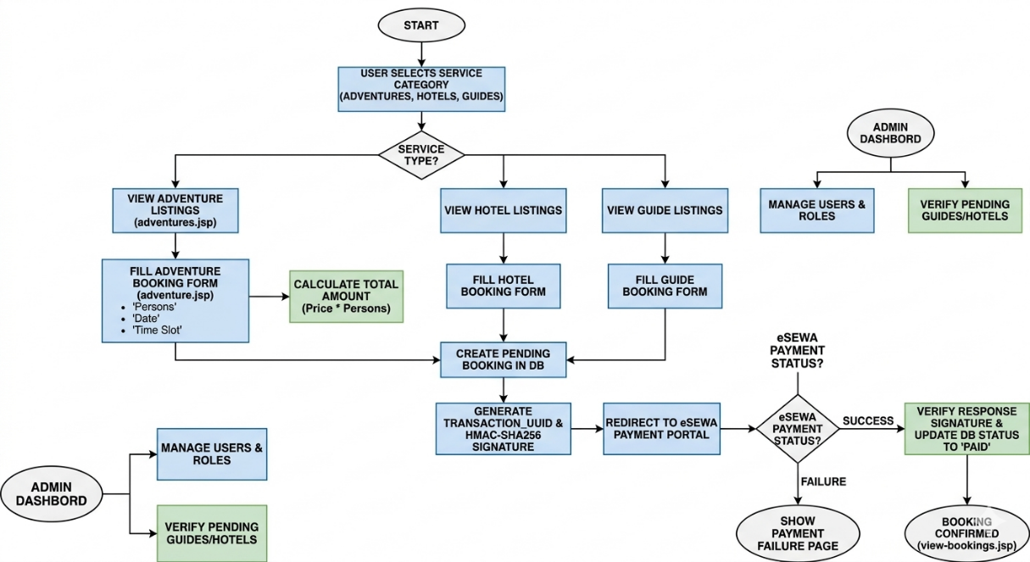

Fig 3.4.1: Flowchart Ghumantey

3.4.2 Class Diagram for “Ghumantey”:

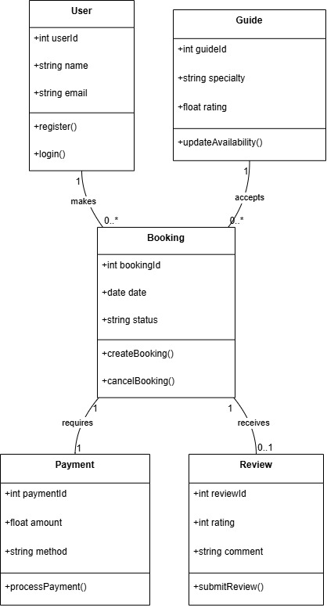

Fig 3.4.2: Class Diagram Ghumantey

3.4.3. Sequence Diagram for “Ghumantey”:

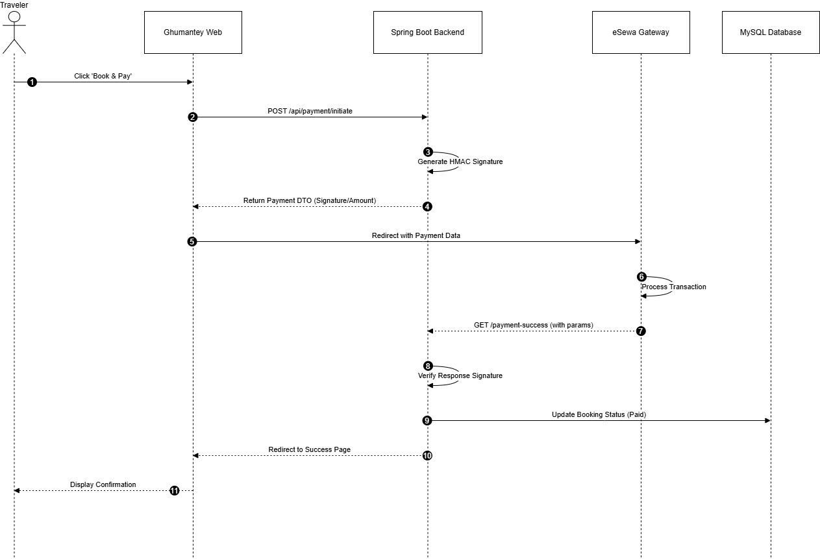
Fig 3.4.3: Sequence Diagram for Ghumantey.

3.4.4. Database Schema for “Ghumantey”:
User_detail table:

Field Name | Data Type | Description
user_id (PK) | INT | Unique ID for each user
full_name | VARCHAR(100) | User’s full name
email | VARCHAR(100) | User’s email address
password | VARCHAR(255) | Encrypted password
phone_number | VARCHAR(20) | Contact number of the user
address | VARCHAR(150) | User’s address or city
role | VARCHAR(20) | Defines role: “USER” or “ADMIN”
created_at | DATETIME | Date and time of account creation

Fig 3.4.4: Database Schema for users.

Guide_details table:

Field Name | Data Type | Description
guide_id (PK) | INT | Unique ID for each guide
full_name | VARCHAR(100) | Guide’s full name
email | VARCHAR(100) | Guide’s email
password | VARCHAR(255) | Encrypted password
phone_number | VARCHAR(20) | Guide’s contact number
language | VARCHAR(50) | Languages spoken by the guide
experience_years | INT | Total years of experience
location | VARCHAR(100) | Location or area of service
rate_per_day | DECIMAL(10,2) | Daily service charge
availability | BOOLEAN | Availability status (true/false)
rating | FLOAT | Average rating given by users

Fig 3.4.4: Database schema for Guide.

3.4.5. “Ghumantey” System Architecture:

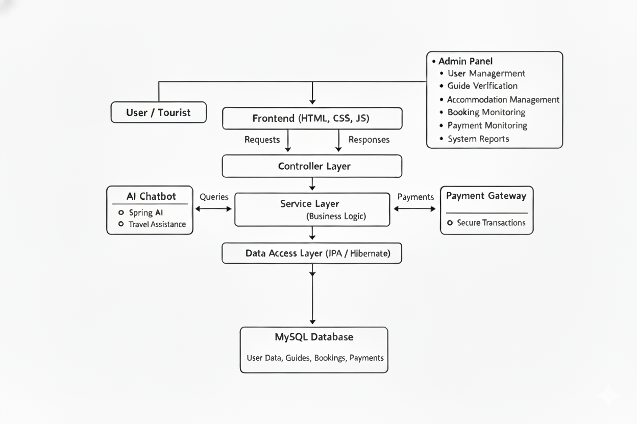
Fig 3.4.5: System Architecture of Ghumantey.

3.4.6. ER-Diagram

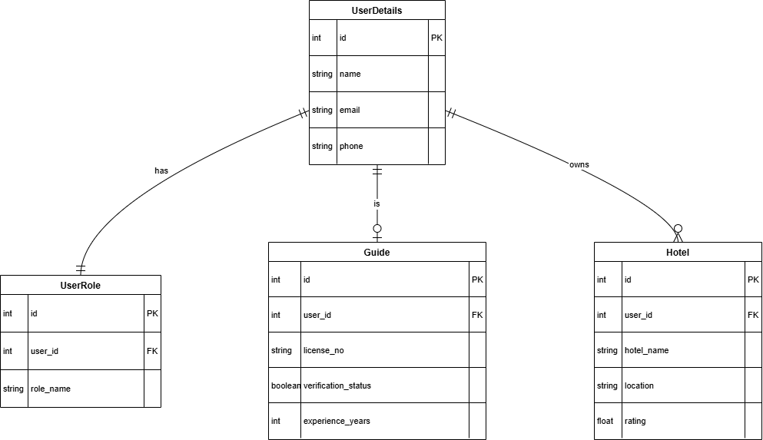

Fig 3.4.6: ER-Diagram of Ghumantey.

3.4.7. DFD-Diagram

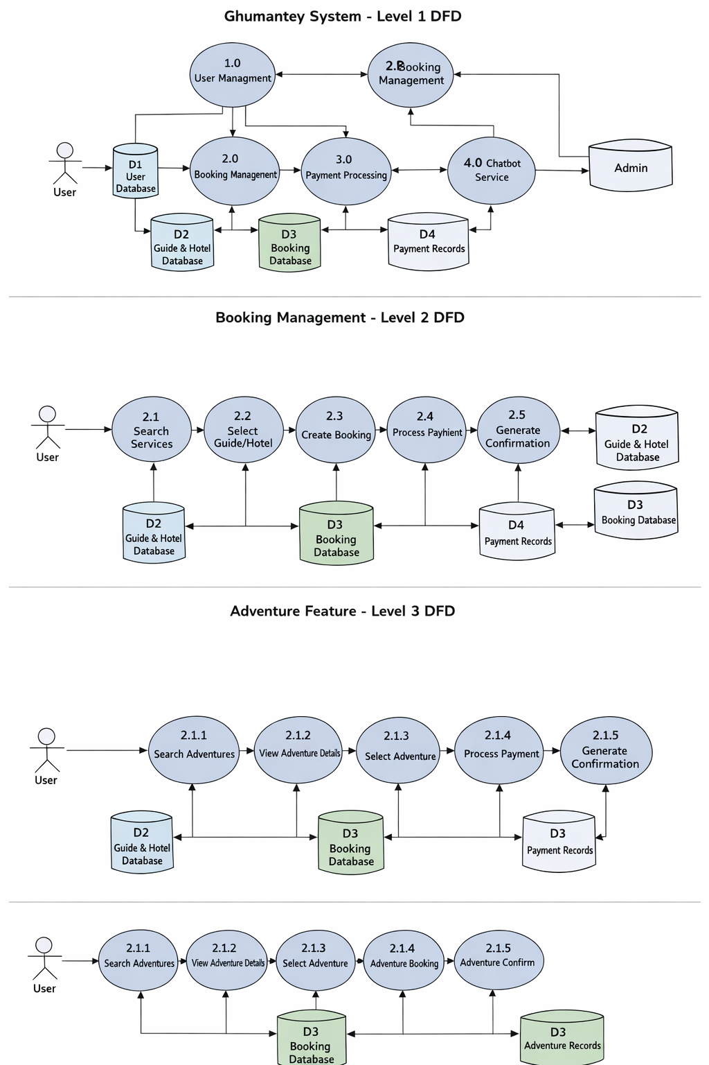

Fig 3.4.7: DFD of Ghumantey

4. IMPLEMENTATION PLAN

4.1 Development Methodology
Ghumantey was developed using the Agile technique, which enables for iterative and flexible development. The project is broken down into smaller pieces and developed in stages. Regular testing and feedback are included into each level to ensure continual progress. This method aids in swiftly spotting problems, reacting to changes, and providing a dependable system.

4.2 Module Breakdown
The system is divided into several functional modules for better organization and development:
- User Module: Handles user registration, login, and profile management.
- Guide Module: Displays available tourist guides and their details.
- Hotel Module: Manages hotel listings and booking functionality.
- Booking Module: Handles booking of guides, hotels, and activities.
- AI Chatbot Module: Provides intelligent responses and travel assistance.
- Admin Module: Allows admin to manage guides, hotels, bookings, and users.

4.3 Tools, Platforms, and Languages
The development of Ghumantey uses modern tools and technologies:
- Frontend: HTML, CSS (Tailwind CSS), JavaScript (used for designing user interface and user interaction)
- Backend: Java Spring Boot (used for handling business logic and APIs)
- Database: MySQL (used for storing and managing data)
- AI Integration: Spring AI (used for chatbot and intelligent responses)
- IDE/Tools: IntelliJ IDEA /Eclipse (used for coding and development)
- Version Control: Git and GitHub (used for code management and collaboration)
- Platform: Web-based application (accessible through web browsers)

4.4. PROJECT TIMELINE (GANTT CHART)
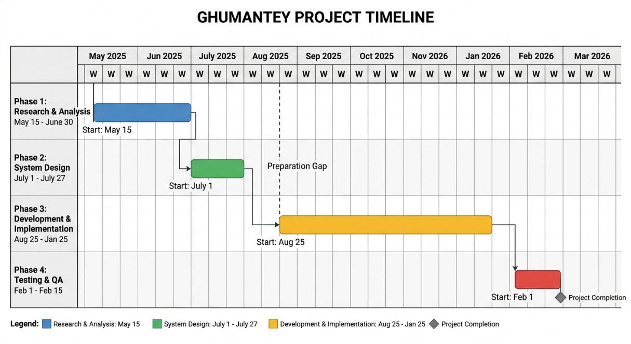

4.5. RISK ANALYSIS

S.N | Risk Description | Likely Hood | Impact | Mitigation Strategy
1 | Delay in completing frontend development due to design complexity | Medium | High | Divide tasks into smaller modules and use Agile sprints to ensure timely progress.
2 | Integration issues between backend and chatbot system | High | High | Test APIs early and integrate chatbot in a test environment before final deployment.
3 | Server or database crash during deployment | Low | High | Keep regular backups and test deployment on a local environment before hosting.
4 | Payment gateway (eSewa) integration failure or bugs | Medium | Medium | Contact eSewa technical support if any issue occurs.

5. EXPECTED OUTCOMES

5.1 Expected Product Features
The Ghumantey system is expected to provide the following features:
- User registration and login functionality
- Search and booking for tourists
- Hotel browsing and reservation system
- Display of travel activities and destinations
- AI-powered chatbot for user assistance
- Admin dashboard for managing guides, hotels, and bookings
- Responsive and user-friendly interface

5.2. Beneficiary
- Tourists: They can easily find and book verified guides, hotels, and activities in one safe place.
- Local Guides: It gives them a digital platform to reach more customers and manage their bookings easily.
- Hotel Owners: They can list their rooms and get more bookings through the app’s automated system.
- Local Economy: By using eSewa, it encourages Nepalese people to travel and spend within the country.
- Admins: The dashboards make it simple to track data and manage the entire tourism network in real-time.

5.3. Limitations
- Only for Fit People: Most of their trips are very difficult and require a lot of hiking, so they aren't easy for families or older people.
- Risky for Beginners: Their videos make dangerous places look easy, which might lead untrained people to take risks they aren't ready for.
- Crowding Nature: When they show a "secret" beautiful spot, too many people go there at once, which can lead to more trash and pollution.
- Missing Details: They focus more on beautiful videos than on giving exact prices, phone numbers, or step-by-step directions.
- Expensive Gear: Their style of travel often requires costly trekking equipment and clothes that not everyone can afford.

6. CONCLUSION & RESULT

6.1. Conclusion
"Ghumantey" is a digital tourism platform that aims to improve Nepal's travel business by linking travelers with trusted local guides, hotels, and authentic travel services. It includes features such as AI-powered chatbot help, safe eSewa payment integration, and user-friendly travel planning. The approach benefits both domestic and foreign passengers, boosts local businesses, and encourages sustainable tourism by emphasizing rural regions. The initiative focuses on technical innovation, community empowerment, and travel convenience via a single digital platform.

6.2. Result
The Ghumantey platform has effectively established a consolidated digital ecosystem, transforming Nepal's conventional travel scene into a more streamlined, user-centric experience. By combining destination discovery, lodging booking, and licensed guide administration into a single interface, the initiative successfully reduces the fragmentation that is typical of regional travel planning. The findings show a major bridge of the gap between foreign visitors and local service providers, offering a professional platform for small hotels and hidden treasures to access a worldwide market. Furthermore, the portal acts as an important driver for economic growth and cultural preservation by offering a specialized internet marketplace for genuine Nepalese handicraft. Finally, Ghumantey simplifies the process from planning to purchasing, ensuring that local artists and hospitality providers gain maximum publicity while providing tourists with a safe, thorough, and culturally immersing approach to experience the region.

6.3. Future Scope
- Development of a mobile application for easier access and broader reach.
- Addition of AI-based travel recommendations for personalized trip suggestions.
- Integration of multi-language support to attract global users.
- Creating a separate panel for guides and hotels.
- Expansion to include international travel packages and collaborations with global agencies.
- Continuous updates for security, scalability, and performance improvement.
- Upgrading adventures features in the applications

6.4. Summary
The Ghumantey system is a centralized digital ecosystem that aims to modernize and professionalize Nepal's tourist industry. At its heart, the platform acts as a safe link between tourists and local service providers, relying on a strong verification mechanism to verify that all guides and hotels are certified by legitimate tourism agencies. This system goes beyond basic reservations by incorporating adventure management modules that allow visitors to explore treks by difficulty while also giving local hosts with a dedicated dashboard to manage their listings and availability directly. Technically, the system is designed for dependability and security, using local payment gateways such as eSewa and HMAC-SHA256 signature verification to ensure transaction security. By concentrating on local empowerment, the app eliminates traditional intermediaries, ensuring that tourist revenue stays in rural areas while providing guests with "ghumVerified" alternatives for a more real experience. Furthermore, the system is built to scale with cutting-edge capabilities like AI-powered support for real-time travel guidance and automated administrative supervision to ensure safety and service quality throughout the platform.

7. REFERENCES
- Paudel, B. P. (2019). Opportunities and Challenges of Tourism in Nepal. Tribhuvan University Journal, Nepal Journals Online (NepJOL).
- GetYourGuide. (n.d.). Online tour booking system with verified local guides.
- Hamro Trip. (n.d.). Online travel and flight booking platform.
- TripAdvisor. (n.d.). Official travel and guide platform providing hotel listings, travel reviews, and destination information.
- Visit Nepal. (n.d.). Official tourism portal of Nepal providing travel information and destination guides.

.

8. APPENDICES

8.1 User Interface:

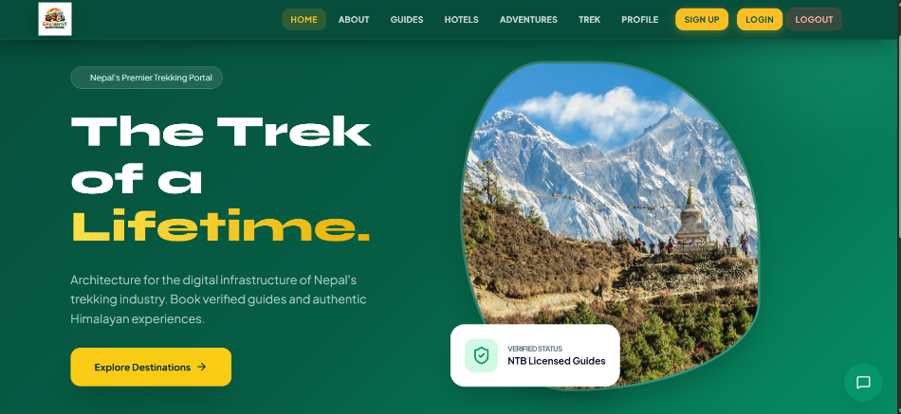
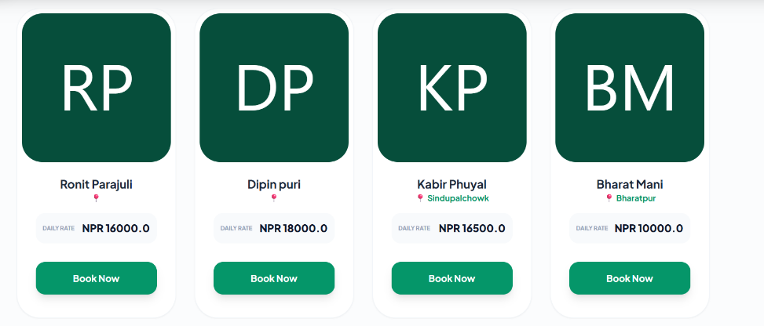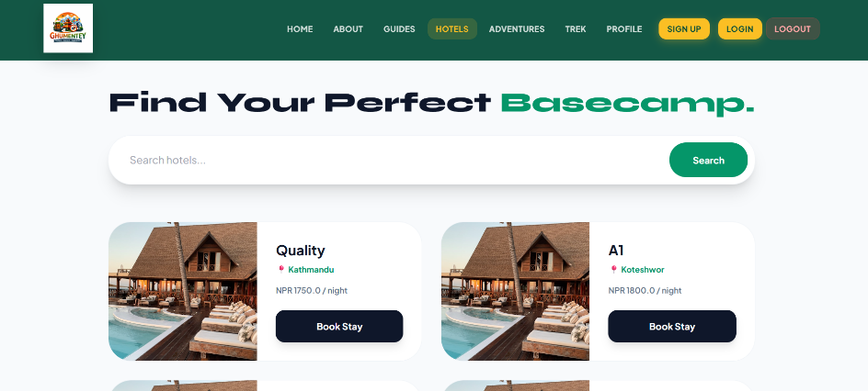
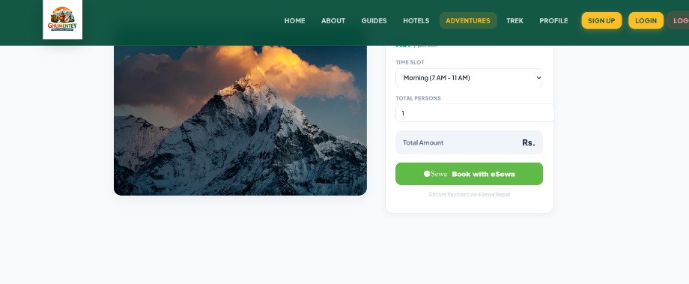
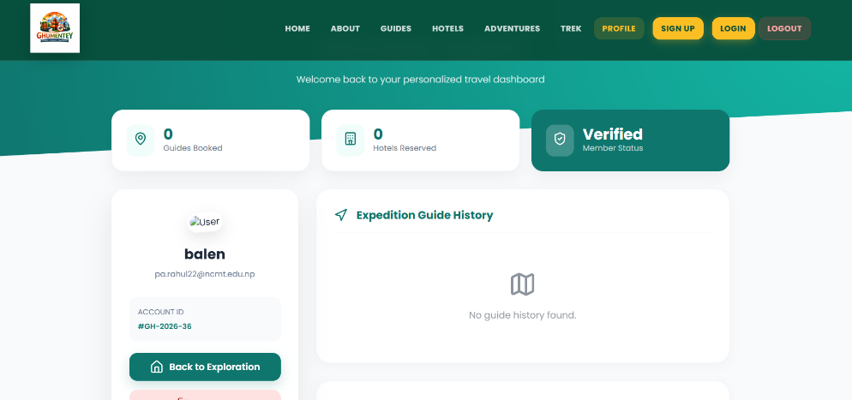

8.2 Admin Panel:
